
Solution Architecture

Date | 15 September 2026
Team ID | SWTID-2026-7879
Project Name | Script-Controlled ACL – Restrict Record Access Based on Field Value
Maximum Marks | 5 Marks

Solution Architecture Diagram:
Provide a high-level visual representation of your solution's architecture. Use the structural layout below as a template to map out your Presentation Layer, Application Layer, and Data Layer. Fill in the specific technologies and components for your project directly into the boxes to create your architectural diagram.

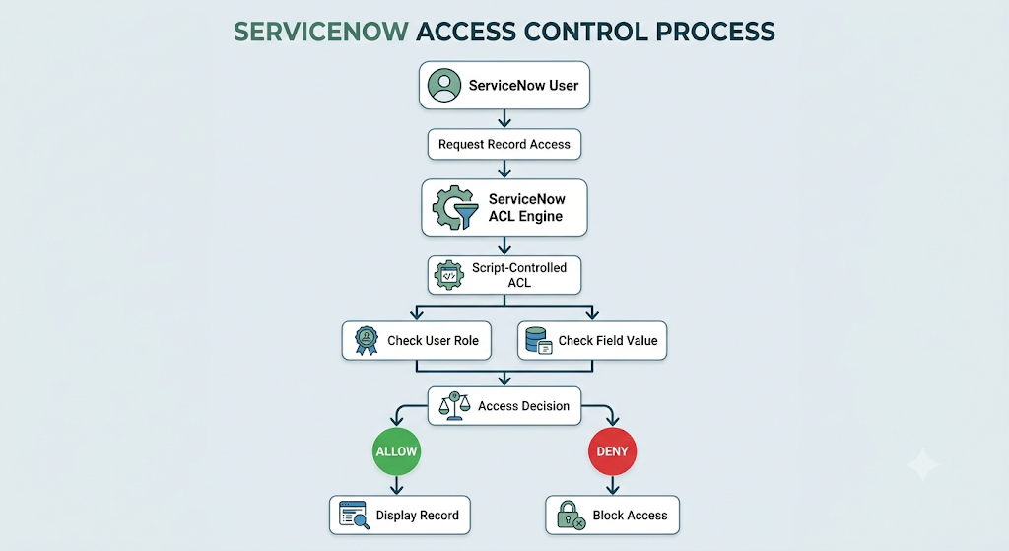

Component Description Table

Component Name | Description / Role | Technology
Presentation Layer | User accesses ServiceNow records | ServiceNow UI
ACL Engine | Processes access requests | ServiceNow ACL
Script Logic | Evaluates user and record conditions | JavaScript
Record Table | Stores records and field values | ServiceNow Database
User/Role System | Provides user identity and roles | ServiceNow

